Program 1: WAP to calculate the real root of the equation ax²+bx+c=0
using the quadratic formula
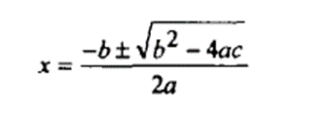
Test with a=1, b=-7 , c=12, roots are 3 and 4
Source Code:
#include<stdio.h>
#include<math.h>
int main()
{
int a,b,c;
float numerator,root1,root2,root;

printf(" enter a : ");
scanf("%d",&a);

printf("\n enter b : ");
scanf("%d",&b);

printf("\n enter c : ");
scanf("%d",&c);

printf(" \n Quadratic Equation formed:");
printf(" %dx²+%dx+%d",a,b,c);

numerator=pow(b,2)-(4*a*c);

if(numerator<0)
printf("\n no real roots");

else if(numerator>0){
printf("\n real roots");
root1= (-b+sqrt(numerator))/(2*a);
root2=(-b-sqrt(numerator))/(2*a);
printf("\n Roots are %.1f and %.1f",root1,root2);
}

else
{printf("\n same roots");
root= -b/(2*a);
printf("\n root is %f",root);}
return 0;
}

OUTPUT:

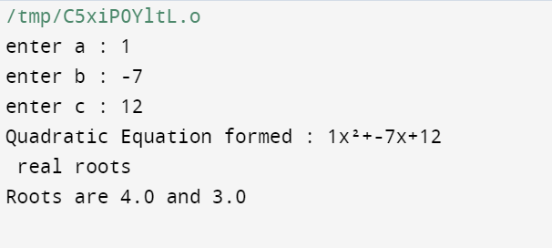

Program 2: WAP to calculate Compound interest using formula
Consider n as 1 in this example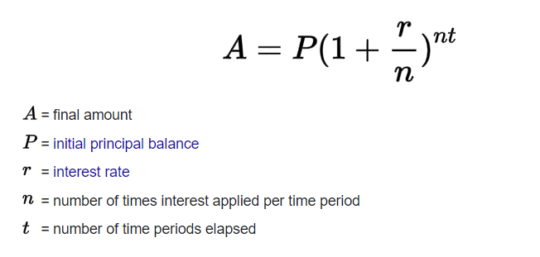
Test with P=1000,r=10% , year =2 , Compound Interest should be 210, Total amount : 1210.

Source Code :
#include <stdio.h>
#include <math.h>
void main(){

int p,temp,t;
float final,middle,r;
printf("Enter the Principal Amount : ");
scanf("%d",&p);

printf("Enter the Time period : ");
scanf("%d",&t);

printf("Enter the Rate of interest : ");
scanf("%f",&r);
r=r/100;
temp=1;

middle=(1+(r/temp));
final=pow(middle,temp*t);
final*=p;

printf("Final Amount is %.1f",final);

}

OUTPUT:

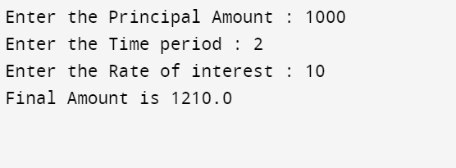

Program 3: WAP to calculate degrees Celsius given temperature in degrees Fahrenheit using the formula

C= (5/9) * (F-32)
Test with following values
68,150,0,-22
degrees celcius 20, 65.55,-17.77,-30

Source Code:

#include <stdio.h>
void main(){

float fah,cel;

printf("Enter the temperature in degree Fahrenheit : ");
scanf("%f",&fah);

cel=0.555555;
fah-=32;
cel*=fah;

printf("temperatue is %.4f degree celcius",cel);

}

Output:

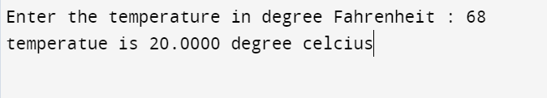
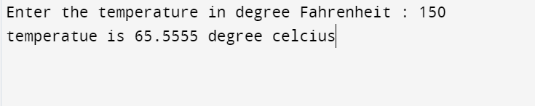

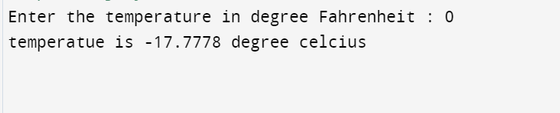

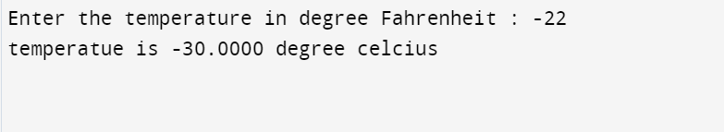

Program 4: WAP to Calculate the volume and area of a sphere using the formulas accept radius from user.
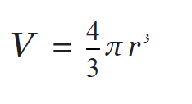
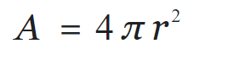
Test with radius=9cm, Volume = 3053.628 cm3 , Area= 1017.87 cm
Source Code:
#include <stdio.h>
#include <math.h>

void main(){

int r;
float ar , vol;
float PI=3.14159;

printf("Enter Radius : ");
scanf("%d",&r);

ar=4*PI*r*r;
printf("area is %.5f\n",ar);

vol=(4*PI*r*r*r)/3;
printf("Volume is %.5f",vol);
}

Output:
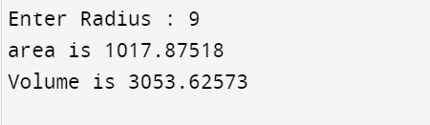

Program 5: WAP to accept a character from user and check whether an alphabet is vowel or consonant using conditional operator.

Source Code:

#include <stdio.h>
void main(){

char ch;
printf("Enter a character : ");
scanf("%c",&ch);
ch=(int)ch;

(ch==65)||(ch==69)||(ch==73)||(ch==79)||(ch==85)|(ch==97)||(ch==101)||(ch==105)||(ch==111)||(ch==117)?printf("Character is vowel"):printf("Character is Constant");
}

Output:

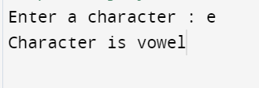

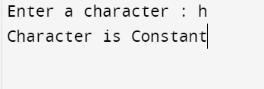
Program 6: Write a Program to calculate diameter, circumference and area of circle accept radius from user.

Source Code:

#include <stdio.h>

void main(){

const float PI=3.14;
int radius;
printf("Enter radius : ");
scanf("%d",&radius);
printf("diameter is %d ", radius*2);
printf("\nCircumference is %.2f\n",2*PI*radius);
printf("Area is %f",PI*radius*radius);
}

OUTPUT:
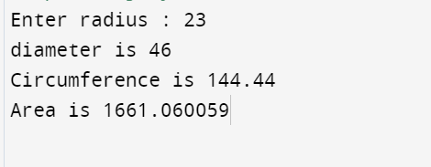
Program 7: WAP to accept number from user and display whether it is even or odd. Hint : use conditional and modulus operator.
Source Code:

#include <stdio.h>
void main(){

int n;
printf("Enter a number : ");
scanf("%d",&n);
(n%2==0)?printf("Number is even"):printf("Number is odd");

}

OUTPUT:

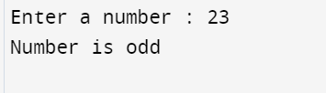

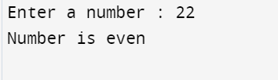

Program 8: WAP to accept a character and display whether it is Capital Letter, Small Letter or Integer value.

Source Code:

#include<stdio.h>
int main()
{ char ch;
printf("enter character : ");
scanf("%c",&ch);
if(ch>64&&ch<91)
printf("Capital letter");
else if(ch>96&&ch<123)
printf("small letter");
else if(ch>47&&ch<58)
printf("integer value");

return 0;
}

OUTPUT:

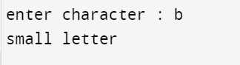
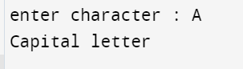

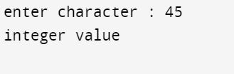
Program 9: Write a Program to count number of digits in any number.

Source Code:

#include<stdio.h>
void main(){
int num,ctr=0;
printf("enter number ");
scanf("%d",&num);
int temp = num;
while(temp>0){
temp/=10;
ctr++;
}
printf("Number of digits :- %d",ctr);
}

OUTPUT:

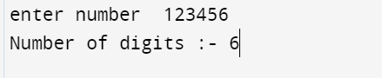
Program 10: Write a Program to find first and last digit of any number display them. Then swap the digits and create a new number and display it.

Source Code:
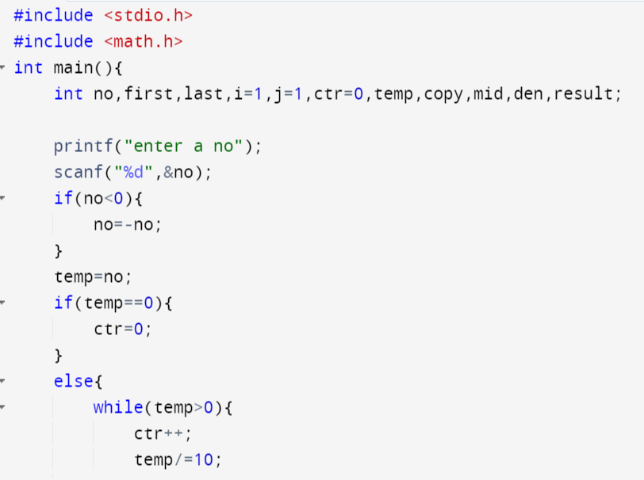
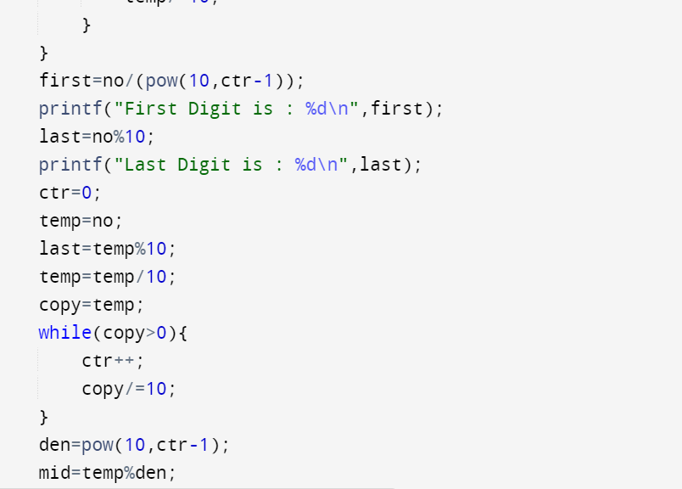
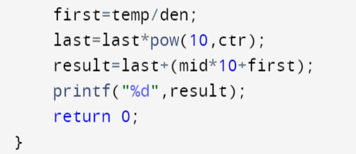

OUTPUT:

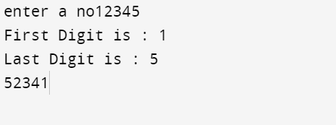

Program 11: Write a Program to enter any number and print all factors of the number.

Source Code:

#include<stdio.h>
int main()
{
int num, i;
printf(" enter a number: ");
scanf("%d",&num);
for(i=2;i<=num;i++)
{ if(num%i==0)
printf("\n %d is a Factor of %d",i,num);
}
return 0;
}

OUTPUT:
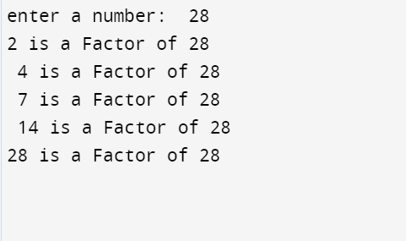
Program 12: Write a Program to enter any number and calculate its factorial.

Source Code:
#include <stdio.h>
int main(){
int num;
printf("enter the number: ");
scanf("%d",&num);
int fct=1;
int i;
for(i=num;i>1;i--){
fct*=i;
}
printf("factorial of %d is %d",num,fct);
}

OUTPUT:

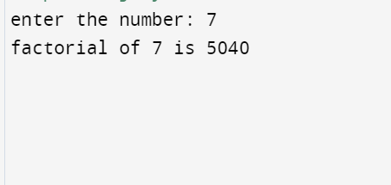
Program 13: Write a Program to find HCF (GCD) of two numbers.

Source Code:
#include<stdio.h>
int main()
{
int num,num2,rem;
printf("enter number 1 and number 2:");
scanf("%d %d",&num,&num2);
while(num%num2>0)

{ rem=num%num2;
num=num2;
num=rem;
}
printf("hcf is %d",num2);
return 0;
}

OUTPUT:
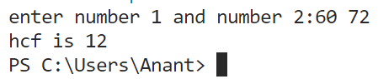
Program 14: Write a Program to find LCM of two numbers.

Soruce Code:

#include<stdio.h>

int main(){
int i,num,num2;

printf(" enter two numbers ");
scanf("%d %d",&num,&num2);

for(i=num1;i<=num*num2;i++){

if(i%num1==0&&i%num2==0){
printf("\n Lcm is %d",i);

break;
}
}
return 0;
}

OUTPUT:
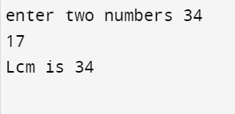
Program 15: Write a Program to check whether a number is Prime number or not.

Source Code:

#include<stdio.h>
int main(){

int num,prime=0,i;

printf("enter number ");
scanf("%d",&num);

for(i=2;i<num;i++){
if (num%i==0){
prime=1;}}
if(prime==0)
printf("%d is a prime number",num);
else
printf("%d is not a prime number",num);

return 0;}

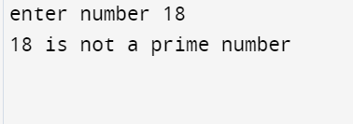
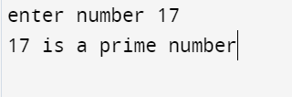
OUTPUT:
Program 16 : Write a Program to find sum of all prime numbers between 1 to n.

Source Code:
#include <stdio.h>
int main()
{
int i,j,n,prime,sum=0;
printf("Find sum of all prime between 1 to : ");
scanf("%d", &n);
for(i=2; i<=n; i++){
prime = 1;
for(j=2; j<=i/2 ;j++){
if(i%j==0){
/* 'i' is not prime */
prime = 0;
break;
}
}
if(prime==1){
sum += i;
}
}
printf("Sum of all prime numbers between 1 to %d = %d",n,sum);
return 0;
}

OUTPUT:

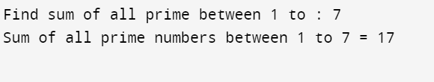
Program 17: Write a function Power (a,b), to calculate the value of a raised to the power of b.

Source Code:

#include <stdio.h>
int power(int a,int b);
int main(){
int num,num2,res;
printf("enter number ");
scanf("%d",&num);
printf("enter power of number ");
scanf("%d",&num2);
res=power(num,num2);
printf("ANSWER :- %d",res);
}

int power(int a,int b){
int mul=1,i;
for(i=1;i<=b;i++){
mul*=a;
}
return mul;
}

OUTPUT:

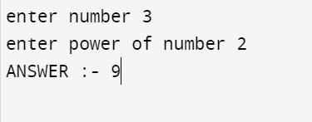
Program 18: Write a function Primefactor(a) , to calculate the prime factors of a number and display the result in the function.
Source Code:
#include <stdio.h>
int Primefactor(int a);
int main() {
int num, res;
printf("Enter Number to check: ");
scanf("%d", &num);
res = Primefactor(num);
return 0;
}
int Primefactor(int a) {
int i, j, prime = 0, cnt = 0;
for (i = 2; i <= a; i++) {
if (a%i == 0) {
prime = 1;
for (j = 2; j <= i / 2; j++) {
if (i % j == 0) {
prime = 0;
break;
}
}
if (prime == 1) {

printf("prime factor:-%d\n", i);
while (a % i == 0) {
a /= i;
cnt++;
}
}
}
}
return cnt;
}

OUTPUT:
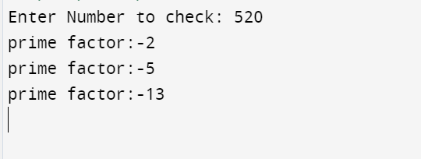
Program 19: Write a function Stddev(a,b,c,d,e) that receives 5 integers and displays the sum, average and the standard deviation of these numbers.

Source Code:

#include <stdio.h>
#include <math.h>

void Stddev(int a, int b, int c, int d, int e) {

int numbers[5] = {a, b, c, d, e};
int n = 5;
int sum = 0;

double average, variance, stddev;

for (int i = 0; i < n; i++) {
sum += numbers[i];
}
average = (double)sum / n;
variance = 0;
for (int i = 0; i < n; i++) {
variance += pow(numbers[i] - average, 2);
}

variance /= n;

stddev = sqrt(variance);

printf("Sum: %d\n", sum);
printf("Average: %.2f\n", average);
printf("Standard Deviation: %.2f\n", stddev);
}

int main() {

Stddev(6, 7, 8, 9, 10);

return 0;
}

OUTPUT:

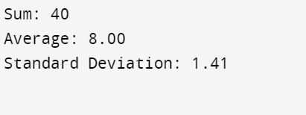
Program 20 : Write a function Palindrome(a), that accepts an integer and return 1 if the number is a palindrome number and return 0 if it is not.

Source Code:
#include<stdio.h>
int palindrome(int n);

int main(){

int num;
printf("Enter A No ");
scanf("%d",&num);
num=palindrome(num);
printf("%d",num);
return 0;

}

int palindrome(int n)
{
int r=0,b;
b=n;

while (n>0){
r=r*10+(n%10);
n/=10;
}

if(b==r)
printf("The number is a palindrome\n");

else
printf("The number is a palindrome\n");
}

OUTPUT:

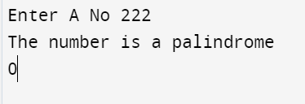
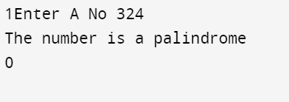
Program 21: Write a recursive function GCDRec(a,b), that accepts two integer values and returns the GCD of two numbers.
Source Code:
#include <stdio.h>

int GCDRec(int a, int b) {

if (b == 0) {
return a;
}
else {
return GCDRec(b, a % b);
}
}

int main() {
int num, num2;

printf("Enter two numbers: ");
scanf("%d %d", &num, &num2);

int hcf = GCDRec(num, num2);

printf("GCD of %d and %d is: %d\n", num, num2, hcf);

return 0;
}

OUTPUT:

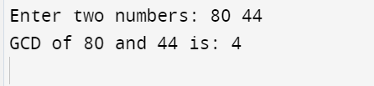
Program 22: Write a recursive function FiboRec(a), that accepts number of terms to be displayed in fibonacci series starting with 1 ,1 .

Source Code:

#include <stdio.h>

int FiboRec(int a) {

if (a <= 1) {
return a;
} else {
return FiboRec(a - 1) + FiboRec(a - 2);
}
}

int main() {

int num;

printf("Enter the number of terms in the Fibonacci series: ");
scanf("%d", &num);

printf("Fibonacci Series: ");

for (int i = 1; i <= num; i++) {
printf("%d ", FiboRec(i));
}
printf("\n");

return 0;
}

OUTPUT:

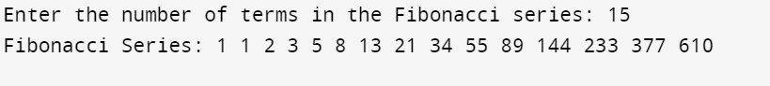
Program 23: Write a recursive fuctionSumTermRec(a), that accepts an integer value and return the sum of all the digits.
Source Code:

#include <stdio.h>

int SumTermRec(int a) {

if (a == 0) {
return 0;
} else {
return (a % 10) + SumTermRec(a / 10);
}
}

int main() {

int num;

printf("Enter integer: ");
scanf("%d", &num);

int s= SumTermRec(num);

printf("Sum of digits of %d is: %d\n", num, s);

return 0;
}

OUTPUT:
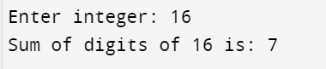
Program 24: Write a recursive function DectoBinaryRec(a), that accepts an integer and return Binary equivalent of the decimal number.
Source Code:
#include <stdio.h>

int DectoBinaryRec(int dec) {

if (dec == 0) {
return 0;
} else {
return (dec % 2) + 10 * DectoBinaryRec(dec / 2);
}
}

int main() {

int num, bin;
printf("Enter a decimal number: ");
scanf("%d", &num);

if (num == 0) {
printf("Binary equivalent: 0\n");
return 0;
}

bin = DectoBinaryRec(num);

printf("Binary equivalent: %d\n", bin);

return 0;
}

OUTPUT:

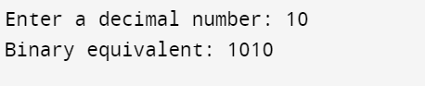

Program 25: Write a Program to count frequency of each element in an array.
Source Code:

#include <stdio.h>

void frequency(int arr[], int size) {

int mostfreq = arr[0];

for (int i = 1; i < size; i++) {

if (arr[i] > mostfreq) {
mostfreq = arr[i];
}
}

int freq[mostfreq + 1];

for (int i = 0; i <= mostfreq; i++) {
freq[i] = 0;
}

for (int i = 0; i < size; i++) {
freq[arr[i]]++;
}

printf("Element\tFrequency\n");

for (int i = 0; i <= mostfreq; i++) {
if (freq[i] != 0) {
printf("%d\t : %d\n", i, freq[i]);
}
}
}
int main() {

int arr[10];

for(int i=0;i<10;i++){

printf("Enter element %d: ",i+1);
scanf("%d",&arr[i]);
}

int size = sizeof(arr) / sizeof(arr[0]);

frequency(arr, size);

return 0;
}

OUTPUT:

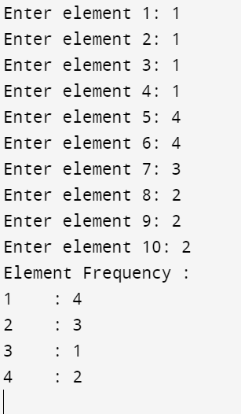
Program 26: Write a Program to print unique elements of array.
Source Code:

#include <stdio.h>

void unique(int arr[],int size);

int main(){

int no;

printf("Enter number of elements ");
scanf("%d",&no);

int arr[no];

for (int i = 0; i<no ; i++){
printf("Enter element no. %d : ",i+1);
scanf("%d",&arr[i]);
}

unique(arr,no);
return 0;
}

void unique(int arr[],int size){
int unique[size],cnt=0;

for (int i = 0; i < size; i++){
unique[i]=0;
}

for (int i = 0; i < size; i++){
cnt=0;

for (int j = 0; j < size; j++){
if (arr[i]==unique[j]){
cnt=1;
break;
}
}

if (cnt==0){
unique[i]=arr[i];
}
}

printf("Unique Elements in array are : -");

for (int i = 0; i < size; i++){

if(unique[i]){

printf("%d ",unique[i]);
}
}

}

OUTPUT:

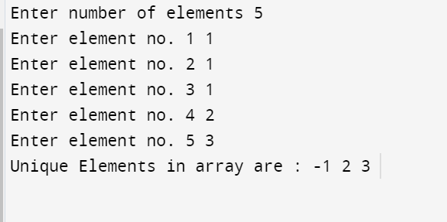

Program 27: Write a Program to find reverse of an array.
Source Code:

#include <stdio.h>

int main(){

int num;

printf("Number of elements in the array : ");
scanf("%d",&num);

int arr[num];

for (int i = 0; i < num; i++){

printf("Enter element %d : "i+1);
scanf("%d",&arr[i]);

}

int reverse[num];

for(int i=num-1;i>=0;i--){
reverse[i]=arr[num-i-1];
}

printf("Original Array :-");

for (int i = 0; i < num; i++){

printf("%d ",arr[i]);

}

printf("\n");
printf("Reversed Array :- ");

for (int i = 0; i < num; i++){
printf("%d ",reverse[i]);
}

return 0;

}

OUTPUT:

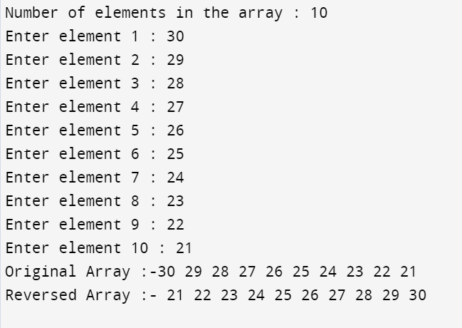
Program 28: Write a Program to merge two arrays to third array.
Source Code:
#include <stdio.h>
#include <stdlib.h>
int main(){

int s1,s2,i;
printf("Enter size of first array : ");
scanf("%d",&s1);
printf("Enter size of second array : ");
scanf("%d",&s2);

int arr1[s1],arr2[s2],newArr[s1+s2];

for (i = 0; i < s1; i++){
printf("Enter element for array 1 : ");
scanf("%d",&arr1[i]);
}

for (i = 0; i < s2; i++){
printf("Enter element for array 2 : ");
scanf("%d",&arr2[i]);
}

for (i = 0; i < s1; i++){
newArr[i]=arr1[i];
}

for (i = 0; i < s1 + s2; i++){
newArr[i+s1]=arr2[i];
}

for (i = 0; i < s1+s2; i++){
printf("%d\t",newArr[i]);
}

return 0;

}

OUTPUT:
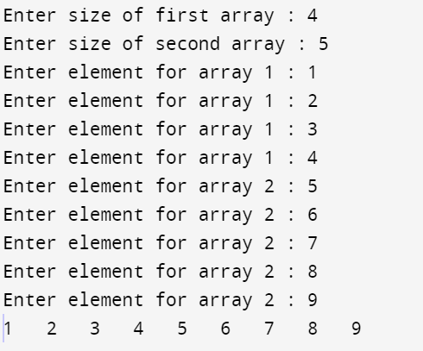
Program 29: Write a program to accept 5 elements, performs sorting operation with two functions :SelectionSortAsc(), SelectionSortDesc().
Source Code:

#include <stdio.h>
#include <stdlib.h>

void SelectionSortAsc(int arr[], int n) {
for (int i = 0; i< n - 1; i++) {
int min = i;
for (int j = i + 1; j < n; j++) {
if (arr[j] <arr[min]) {
min = j;
}
}
int tmp = arr[i];
arr[i] = arr[min];
arr[min] = tmp;
}
}
void SelectionSortDesc(int arr[], int n) {
for (int i = 0; i< n - 1; i++) {
int max = i;
for (int j = i + 1; j < n; j++) {
if (arr[j] >arr[max]) {
max = j;
}
}
int tmp = arr[i];
arr[i] = arr[max];
arr[max] = tmp;
}
}
int main() {
int arr[5];
printf("Enter 5 elements: ");

for (int i = 0; i< 5; i++) {
scanf("%d", &arr[i]);
}

printf("Original array: ");

for (int i = 0; i< 5; i++) {
printf("%d ", arr[i]);
}

SelectionSortAsc(arr, 5);
printf("\nSorted in Ascending Order: ");

for (int i = 0; i< 5; i++) {
printf("%d ", arr[i]);
}
SelectionSortDesc(arr, 5);
printf("\nSorted in Descending Order: ");

for (int i = 0; i< 5; i++) {
printf("%d ", arr[i]);
}
return 0;
}

OUTPUT:
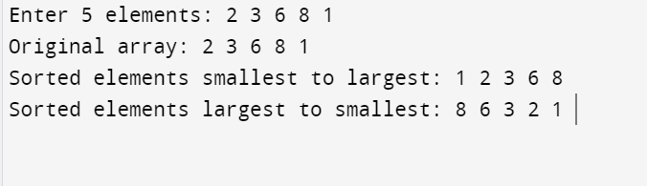

Program 30: Write a Program to delete a specific element specified by the user and then shift all the elements towards left and last element will become zero.
Source Code:
#include <stdio.h>
void deleteAndShift(int arr[], int n, int pos) {

if (pos < 0 || pos >= n) {
printf("Invalid position\n");
return;
}

for (int i = pos; i< n - 1; i++) {
arr[i] = arr[i + 1];
}
arr[n - 1] = 0;
}
int main() {
int arr[5],i;

for (int i=0;i<5;i++){
printf("Enter element number %d:",i+1);
scanf("%d",&arr[i]);
}
printf("Original array: ");

for (int i = 0; i< 5; i++) {
printf("%d ", arr[i]);
}
int position;
printf("\nEnter the position to delete (0-4): ");
scanf("%d", &position);
deleteAndShift(arr, 5, position);
printf("Array after deleting and shifting: ");

for (int i = 0; i< 5; i++) {
printf("%d ", arr[i]);
}
return 0;
}

OUTPUT:

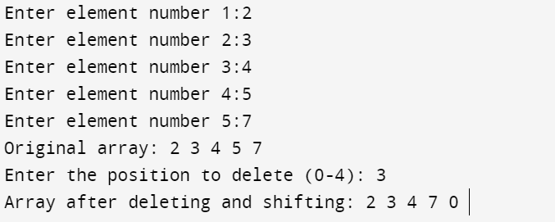

Program 31: Write a Program to accept elements in 2D matrix of size 3x3. Find whether it is skew symmetric matrix or not.
Source Code:

#include <stdio.h>
int skew(int matrix[3][3]) {
for (int i = 0; i< 3; i++) {
for (int j = 0; j < 3; j++) {
if (matrix[i][j] != -matrix[j][i]) {
return 0; // Not skew-symmetric
}
}
}
return 1; // Skew-symmetric
}
int main() {
int matrix[3][3];
printf("Enter elements of 3X3 matrix:\n");

for (int i = 0; i< 3; i++) {
for (int j = 0; j < 3; j++) {
scanf("%d", &matrix[i][j]);
}
}

if (skew(matrix)) {
printf("The matrix is a skew-symmetric matrix.\n");
} else {
printf("The matrix is not a skew-symmetric matrix.\n");
}

return 0;
}

OUTPUT:

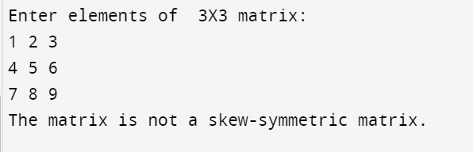

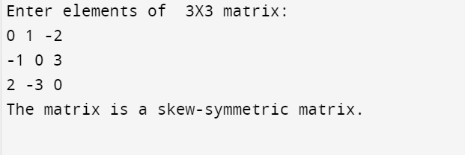

Program 32: Write a Program to accept elements in 2D matrix of size 3x3. Find whether it is symmetric matrix or not.
Source Code:

#include <stdio.h>

int symm(int matrix[3][3]) {
for (int i = 0; i< 3; i++) {
for (int j = 0; j < 3; j++) {
if (matrix[i][j] != matrix[j][i]) {
return 0; // Not symmetric
}
}
}
return 1; // Symmetric
}

int main() {
int matrix[3][3];
printf("Enter elements of a 3x3 matrix:\n");
for (int i = 0; i< 3; i++) {
for (int j = 0; j < 3; j++) {
scanf("%d", &matrix[i][j]);
}
}
if (symm(matrix)) {
printf("The matrix is a symmetric matrix.\n");
} else {
printf("The matrix is not a symmetric matrix.\n");
}

return 0;
}

OUTPUT:
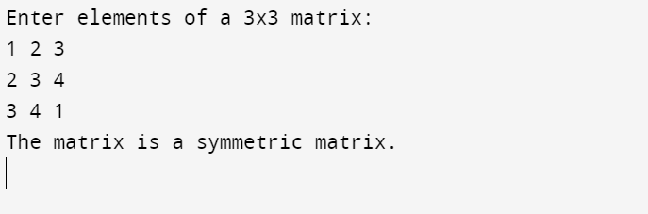

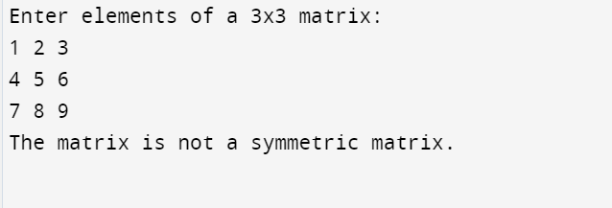

Program 33: Create a header file xstring.h and include string manipulation/handling functions, show its use.
Source Code:

#include <stdio.h>
#include <stdlib.h>

int xstrlen(const char *s) {
int length = 0;
while (*s != '\0') {
length++;
s++;
}
return length;
}

void xstrcpy(char *s1, const char *s2) {
while (*s2 != '\0') {
*s1 = *s2;
s1++;
s2++;
}
*s1 = '\0'; // Add null terminator to the end
}

int xstrcmp(const char *s1, const char *s2) {
while (*s1 != '\0' && *s2 != '\0') {
if (*s1 != *s2) {
return (*s1 > *s2) ?1 : -1;
}
s1++;
s2++;
}
return 0;
}

void xtoupper(char *s) {
while (*s != '\0') {
if (*s >= 'a' && *s <= 'z') {
*s -= 32; // Convert to uppercase
}
s++;
}
}

void xtolower(char *s) {
while (*s != '\0') {
if (*s >= 'A' && *s <= 'Z') {
*s += 32; // Convert to lowercase
}
s++;
}
}

void xstrcat(char *s1, const char *s2) {
while (*s1 != '\0') {
s1++;
}
while (*s2 != '\0') {
*s1 = *s2;
s1++;
s2++;
}
*s1 = '\0'; // Add null terminator to the end
}

void xstrncat(char *s1, const char *s2, int n) {
while (*s1 != '\0') {
s1++;
}
while (*s2 != '\0' && n > 0) {
*s1 = *s2;
s1++;
s2++;
n--;
}
*s1 = '\0'; // Add null terminator to the end
}

void xstrrev(char *s) {
int length = xstrlen(s);
char *start = s;
char *end = s + length - 1;

while (start < end) {
// Swap characters
char temp = *start;
*start = *end;
*end = temp;

// Move towards the center
start++;
end--;
}
}

int xstrchr(const char *s, char c) {
int index = 0;
while (*s != '\0') {
if (*s == c) {
return index;
}
s++;
index++;
}
return -1; // Character not found
}

int xstrstr(const char *s1, const char *s2) {
int index = 0;
while (*s1 != '\0') {
const char *temp_s1 = s1;
const char *temp_s2 = s2;

while (*temp_s1 == *temp_s2 && *temp_s2 != '\0') {
temp_s1++;
temp_s2++;
}

if (*temp_s2 == '\0') {
return index; // Substring found
}

s1++;
index++;
}

return -1; // Substring not found
}
Using the header file in a c program
#include <stdio.h>
#include "xstring.h"

int main() {
char str1[50] = "Hello";
char str2[50] = "World";
printf("Length of str1: %d\n", xstrlen(str1));

xstrcpy(str1, str2);
printf("After copying, str1: %s\n", str1);
printf("Comparison result: %d\n", xstrcmp(str1, str2));

xtoupper(str1);
printf("Uppercase str1: %s\n", str1);

xtolower(str1);
printf("Lowercase str1: %s\n", str1);

xstrcat(str1, str2);
printf("After concatenation, str1: %s\n", str1);

xstrncat(str1, str2, 2);
printf("After concatenation of 2 characters, str1: %s\n", str1);

xstrrev(str1);
printf("After reversal, str1: %s\n", str1);
printf("Index of 'e' in str1: %d\n", xstrchr(str1, 'e'));
printf("Index of 'lo' in str1: %d\n", xstrstr(str1, "lo"));

return 0;
}
OUTPUT:

Program 34: Write program to create a structure … date with members int day,month, year.Create Structure Array of 10 elements. Write function to display details of all the data, display details of specific account holder.
Source Code:
#include <stdio.h>
struct Date {
int day;
int month;
int year;
};
struct Account {
char act_name[20];
int act_no;
char acctype[10];
float act_bal;
struct Date openingbalance;
};
void displayAll(struct Account accounts[], int size) {
printf("Details of all accounts:\n");
for (int i = 0; i< size; ++i) {
printf("Account %d:\n", i + 1);
printf("Name: %s\n", accounts[i].act_name);
printf("Account Number: %d\n", accounts[i].act_no);
printf("Account Type: %s\n", accounts[i].acctype);
printf("act_bal: %.2f\n", accounts[i].act_bal);
printf("Opening Date: %d/%d/%d\n", accounts[i].openingbalance.day, accounts[i].openingbalance.month, accounts[i].openingbalance.year);
printf("\n");
}
}
void displayAccount(struct Account accounts[], int size, int accountNumber) {
for (int i = 0; i< size; ++i) {
if (accounts[i].act_no == accountNumber) {
printf("Details of account with Number %d:\n", accountNumber);
printf("Name: %s\n", accounts[i].act_name);
printf("Account Type: %s\n", accounts[i].acctype);
printf("act_bal: %.2f\n", accounts[i].act_bal);
printf("Opening Date: %d/%d/%d\n", accounts[i].openingbalance.day, accounts[i].openingbalance.month, accounts[i].openingbalance.year);
return;
}
}
printf("Account with Account Number %d not found.\n", accountNumber);
}
int main() {
struct Account accounts[10] = {
{ "sukhbir", 2011, "Savings", 450009.0, { 25, 07, 2005 } },
{ "singh", 2012, "current", 50000.0, { 25, 07, 2005 } },
{ "sareen", 2013, "Savings", 21300.0, {25, 07, 2005} },
{ "varun", 2014, "Investment", 115000.0, { 25, 07, 2005 } },
{ "negi", 2015, "current", 230000.0, { 20, 04, 2022 } },
{ "vansh", 2016, "Savings", 230000.0, { 14, 12, 2023 } },
{ "arora", 2017, "current", 34040.0, { 18, 07, 2012 } },
{ "karam", 2018, "Savings", 234200.0, { 28, 1, 2009 } },
{ "raman", 2019, "Investment", 236000.0, { 30, 03, 204 } },
{ "Anmol", 2020, "current", 400500.0, { 21, 4, 2023 } }
};

int accountNumber;
printf("Enter the Account Number to display details: ");
scanf("%d", &accountNumber);
displayAccount(accounts, 10, accountNumber);

return 0;
}

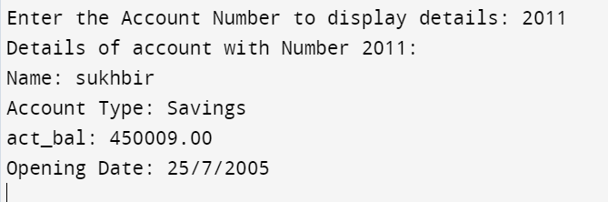
OUTPUT:

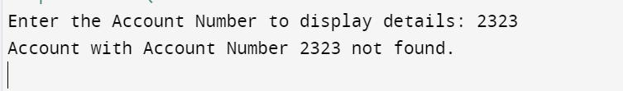
Program 35:
Write a program to create a union Color with members int colorcode, char hexa[10].
Create structure Garments with members int garmentid, char garmentname[20], float cost, union color Clothcolor.
Create structure member and display the details.

Source Code:

#include <stdio.h>

union Color {
int colorcode;
char hexa[10];
};

struct Garments {
int garmentid;
char garmentname[20];
float cost;
union Color Clothcolor;
};

void displayGarment(struct Garments garment) {
printf("Garment Details:\n");
printf("Garment ID: %d\n", garment.garmentid);
printf("Garment Name: %s\n", garment.garmentname);
printf("Cost: %.2f\n", garment.cost);
if (garment.Clothcolor.colorcode != 0) {
printf("Color Code: %d\n", garment.Clothcolor.colorcode);
} else {
printf("Hexadecimal Color: %s\n", garment.Clothcolor.hexa);
}
}

int main() {
struct Garments garment1 = {001, "T-shirt", 21.99, {.colorcode = 0xFF4733}};
displayGarment(garment1);

struct Garments garment2 = {002, "Jeans", 59.99, {.hexa = "#112233"}};
displayGarment(garment2);

return 0;
}

OUTPUT:

